**松浦 MC-510V 加工中心参数**

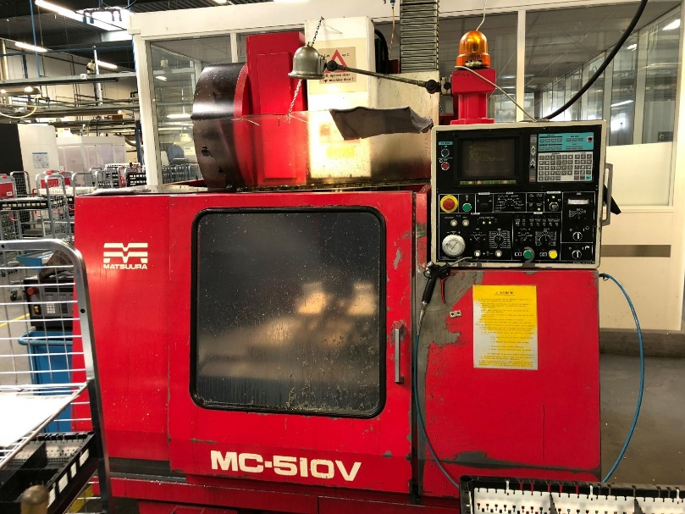

图 1. 松浦 MC-510V 加工中心

(图片来源：https://www.exapro.com/matsuura-mc-510-v-p80904072/)

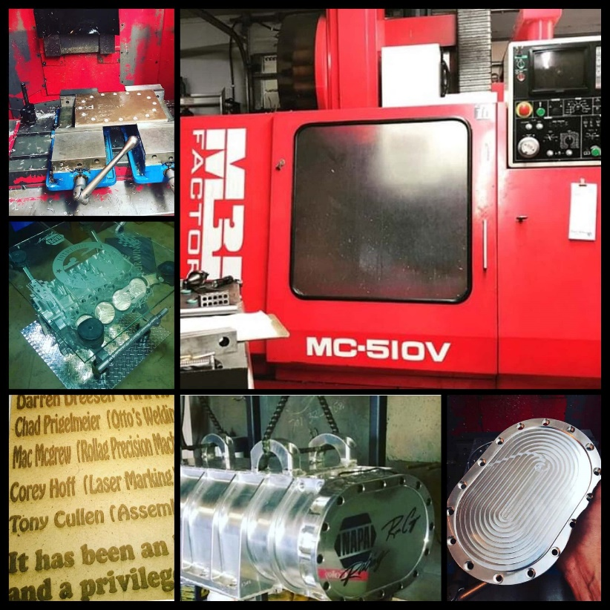

图 2. 松浦 MC-510V 加工中心、工作台及被加工零件

(图片来源： https://www.matsuurausa.com/matsuura-usa-customer-supports-intrepid-fallen-heroes-fund-30-year-old-mc-510v-vertical-machining-center/)

**1. 松浦 MC-510V加工中心参数说明1（https://www.exapro.com/matsuura-mc-510v-p210628048/）**

Axis X: 508 mm

Axis Y: 355 mm

Axis Z: 460 mm

Type of CNC: Yasnac MX 3

Table length: 760 mm

Table width: 380 mm

Max. part weight: 400 kg

Number of tool pockets: 20

Max. spindle speed: 6000 rpm

Spindle motor power: 5.5 kW

Weight: 3800 kg

**2. 松浦 MC-510V加工中心参数说明2 (https://www.machinesused.com/lots/Matsuura-MC-510V-Tiger-CNC-Vertical-Machining-Center-22705)**

Equipped With:

Yasnac MX3 CNC Control, 14.96" x 29.9" T-Slotted Work Table, 20 Station Side-Mount Twin-Arm Tool Changer, BT-35 Taper 6000 Max RPM Spindle, Standard Coolant Tank.

Electrics:

200/220 Volt 3 Phase

Manufacturer: Matsuura Model: MC-510V Year: 1987 Serial Number: 871106386

Main Unit Approx Weight: 8360.00 lbs

Main Unit Dimensions (in inches): Length: 79.00" Width: 96.00" Height: 100.00"

Components:

Coolant Tank: Length: 97.00" Width: 50.00" Height: 10.00"

Specs:

Machine Control: Yasnac MX3 CNC

Table Size: 14.96" x 29.9"

Machine Travels (X/Y/Z): 20"

Spindle Taper: BT 35

Table Capacity: 880 Lbs.

Spindle Speeds: 60 - 6,000 RPM

Rapid Traverse Rate (X/Y/Z): 944 ipm

Spindle To Table Distance: 944 ipm

Tool Changer Style: SideMount Twin-Arm

Maximum Cutting Feed Rate: .1" - 393.7 IPM

Tool Changer Capacity: 20 Station

Spindle Drive: 7.5 HP